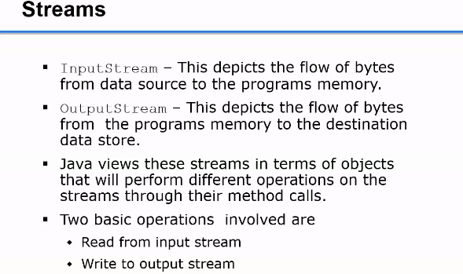

**Java.io package**

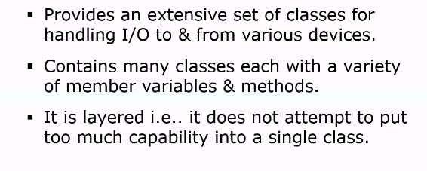

**InputStream** – This depicts the flow of bytes from data source to the program's memory.

**OutputStream** – This depicts the flow of bytes from the program's memory to the destination data store.

Java views these streams in terms of objects that will perform different operations on the streams through their method calls.

Two basic operations involved are

Read from input stream

Write to output stream

**File I/o example code with streams**

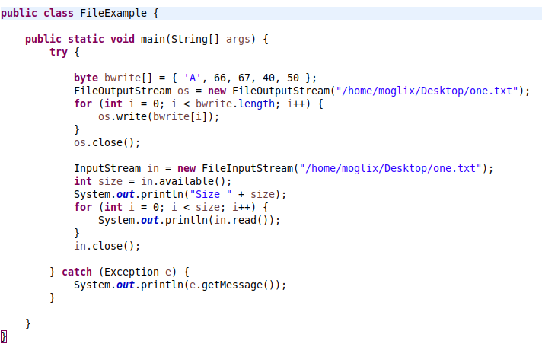

**Reading Excel file example code**



